**Managed Healthcare Executive Advertorial eBlast – August 2021**

**Subject Line: Find Managed Care Reinsurance Coverage Solutions in an Ever-Changing Market**

[1/2 Page Ad “Header”]

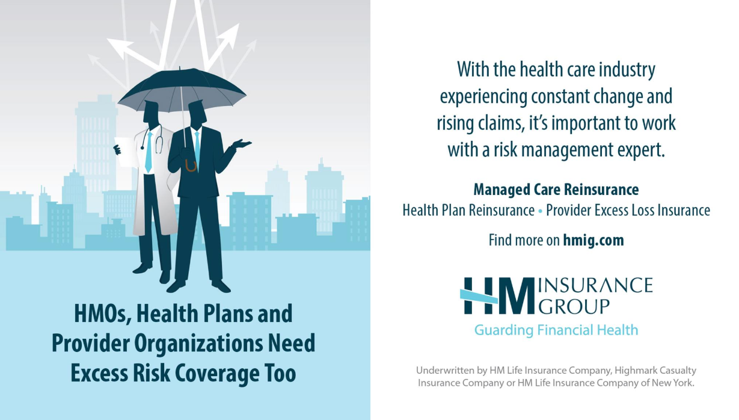

[Headline]  
**Excess Risk Protection in a Changing and Challenging Health Benefits Market**

[Subhead]  
**Find the Right Coverage Solutions**

[Body copy – 175 words max]

As the industry faces significant growth in catastrophic claim costs, excess risk coverage is more important than ever for provider organizations, HMOs and other health plans seeking to protect their bottom line from the potential financial loss and volatility associated with these often multimillion-dollar challenges.

Pharmaceutical advancements like cell and gene therapies with price tags exceeding $1 million are key factors in cost growth. It’s critical to protect against potential coverage gaps, as these treatments evolve rapidly and are only expected to increase. With an incredible pipeline of new high-cost treatments, it’s important to safeguard against these unknown risks.

Financial protection is available. Experienced underwriters at a quality carrier can help to determine the coverage need by assessing the potential for catastrophic claims and how they might impact the client’s balance sheet.

When determining the right carrier, consider:

* AM Best ratings and scale – financial stability and size reflect the ability to make good on promises
* Claim payment resources that emphasize the fair and reasonable interpretation of contracts and claims
* Commitment to consistency
* Desire for long-term, mutually advantageous relationships

[Bulleted feature – 65 words max]

**About HM Insurance Group**

* Companies rated A (Excellent) by AM Best
* Recognized leader in Stop Loss protection
* Combined annual gross revenues of nearly $1 billion
* More than 15 years consistently in the Managed Care Reinsurance market
* Covers millions of commercial, Medicare and Medicaid members
* Has experience with/ability to underwrite specific coverage for Medicare Direct Contracting Entities (DCE)
* Committed to developing long-term relationships
* Approachable team – direct access to underwriting and senior management

(Button): [Connect with HM](https://www.hmig.com/managed-care-reinsurance) [Link to: https://www.hmig.com/managed-care-reinsurance/]

*In all states except New York, products are underwritten by HM Life Insurance Company, Pittsburgh, PA, or Highmark Casualty Insurance Company, Pittsburgh, PA; in New York, products are underwritten by HM Life Insurance Company of New York, New York, NY.*

HM Insurance Group

800-328-5433

www.hmig.com

MTG-3400 (8/21)