**Nutritional Outlook – Cargill Plant-based Booth EBLAST**

**Contact:** [Pam_Stauffer@cargill.com](mailto:Pam_Stauffer@cargill.com)

**Subject:**

Virtual walk through: Plant-based opportunities

**Preheader:**

Top Growth Categories in Plant-based Food

**Preview of Email:**

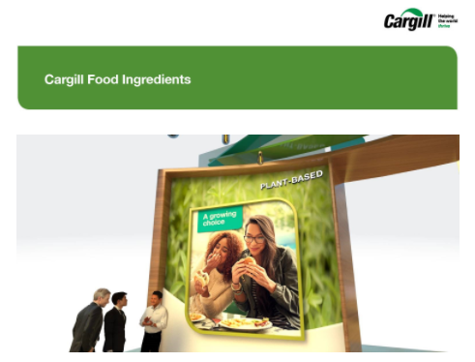

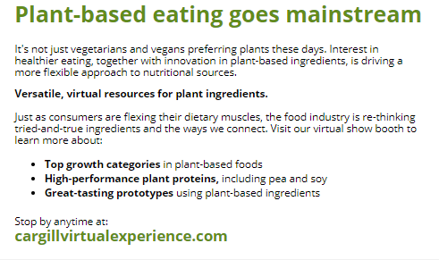

**Images**

Included in the zip file but you need to change the source code in the HTML below based on where you will host the images.

**HTML**

<html>

<body style="background-color:#efefef;"><div style="background-color:#efefef;">

<table cellpadding="0" cellspacing="0" width="100%" role="presentation" style="min-width: 100%; " class="stylingblock-content-wrapper"><tr><td class="stylingblock-content-wrapper camarker-inner"><!--[if mso | IE]><table align="center" border="0" cellpadding="0" cellspacing="0" class="" style="width:600px;" width="600" ><tr><td style="line-height:0px;font-size:0px;mso-line-height-rule:exactly;"><![endif]--><div style="background:#ffffff;background-color:#ffffff;Margin:0px auto;max-width:600px;">

<table align="center" border="0" cellpadding="0" cellspacing="0" role="presentation" style="background:#ffffff;background-color:#ffffff;width:100%;">

<tr>

<td style="direction:ltr;font-size:0px;padding:10px 0px;text-align:center;vertical-align:top;">

<!--[if mso | IE]><table role="presentation" border="0" cellpadding="0" cellspacing="0"><tr><td class="" style="vertical-align:top;width:600px;" ><![endif]--><div class="mj-column-per-100 outlook-group-fix" style="font-size:13px;text-align:left;direction:ltr;display:inline-block;vertical-align:top;width:100%;">

<table border="0" cellpadding="0" cellspacing="0" role="presentation" style="vertical-align:top;" width="100%">

<tr>

<td align="center" style="font-size:0px;padding:10px 25px;word-break:break-word;">

<table border="0" cellpadding="0" cellspacing="0" role="presentation" style="border-collapse:collapse;border-spacing:0px;">

<tr>

<td style="width:550px;">

<img alt="Cargill Food Ingredients" data-assetid="66643" src="https://image.info.cargill.com/lib/fe9d15707366027d76/m/2/3dbfe936-7ba9-499f-b110-57357a878531.jpg" style="display: block; outline: none; text-decoration: none; height: auto; width: 100%; padding: 0px; text-align: center; border: 0px;" width="550"></td></tr></table></td></tr></table></div><!--[if mso | IE]></td></tr></table><![endif]--></td></tr></table></div><!--[if mso | IE]></td></tr></table><![endif]--></td></tr></table><table cellpadding="0" cellspacing="0" width="100%" role="presentation" style="min-width: 100%; " class="stylingblock-content-wrapper"><tr><td class="stylingblock-content-wrapper camarker-inner"><!--[if mso | IE]><table align="center" border="0" cellpadding="0" cellspacing="0" class="" style="width:600px;" width="600" ><tr><td style="line-height:0px;font-size:0px;mso-line-height-rule:exactly;"><![endif]--><div style="background:#ffffff;background-color:#ffffff;Margin:0px auto;max-width:600px;">

<table align="center" border="0" cellpadding="0" cellspacing="0" role="presentation" style="background:#ffffff;background-color:#ffffff;width:100%;">

<tr>

<td style="direction:ltr;font-size:0px;padding:10px 15px 0px;text-align:center;vertical-align:top;">

<!--[if mso | IE]><table role="presentation" border="0" cellpadding="0" cellspacing="0"><tr><td class="" style="vertical-align:top;width:600px;" ><![endif]--><div class="mj-column-per-100 outlook-group-fix" style="font-size:13px;text-align:left;direction:ltr;display:inline-block;vertical-align:top;width:100%;">

<table border="0" cellpadding="0" cellspacing="0" role="presentation" style="vertical-align:top;" width="100%">

<tr>

<td align="center" style="font-size:0px;padding:0px 10px 0px;word-break:break-word;">

<table border="0" cellpadding="0" cellspacing="0" class="full-width-mobile" role="presentation" style="border-collapse:collapse;border-spacing:0px;">

<tr>

<td class="full-width-mobile" style="width:580px;">

<img alt="Plant-based Protein" data-assetid="74414" src="https://image.info.cargill.com/lib/fe9d15707366027d76/m/2/26b7db54-1295-4c5f-b89d-5e51318543f6.jpg" style="display: block; outline: none; text-decoration: none; height: auto; width: 100%; padding: 0px; text-align: center; border: 0px;" width="550"></td></tr></table></td></tr></table></div><!--[if mso | IE]></td></tr></table><![endif]--></td></tr></table></div><!--[if mso | IE]></td></tr></table><![endif]--></td></tr></table><table cellpadding="0" cellspacing="0" width="100%" role="presentation" style="min-width: 100%; " class="stylingblock-content-wrapper"><tr><td class="stylingblock-content-wrapper camarker-inner"><!--[if mso | IE]><table align="center" border="0" cellpadding="0" cellspacing="0" class="" style="width:600px;" width="600" ><tr><td style="line-height:0px;font-size:0px;mso-line-height-rule:exactly;"><![endif]--><div style="background:#ffffff;background-color:#ffffff;Margin:0px auto;max-width:600px;">

<table align="center" border="0" cellpadding="0" cellspacing="0" role="presentation" style="background:#ffffff;background-color:#ffffff;width:100%;">

<tr>

<td style="direction:ltr;font-size:0px;padding:10px 0px;text-align:center;vertical-align:top;">

<!--[if mso | IE]><table role="presentation" border="0" cellpadding="0" cellspacing="0"><tr><td class="" style="vertical-align:top;width:600px;" ><![endif]--><div class="mj-column-per-100 outlook-group-fix" style="font-size:13px;text-align:left;direction:ltr;display:inline-block;vertical-align:top;width:100%;">

<table border="0" cellpadding="0" cellspacing="0" role="presentation" style="vertical-align:top;" width="100%">

<tr>

<td align="left" style="font-size:0px;padding:10px 25px;word-break:break-word;">

<div style="font-family:Open Sans, Arial, sans-serif;font-size:14px;font-weight:normal;line-height:40px;text-align:left;color:#000000;">

<b><span style="font-size:30px;"><span style="color:#638c1c;">Plant-based eating goes mainstream</span></span></b><p style="line-height: 115%;">

It's not just vegetarians and vegans preferring plants these days. Interest in healthier eating, together with innovation in plant-based ingredients, is driving a more flexible approach to nutritional sources.</p><div style="line-height: 115%;">

<b>Versatile, virtual resources for plant ingredients.<br>

​</b>​​​​​​<br>

Just as consumers are flexing their dietary muscles, the food industry is re-thinking tried-and-true ingredients and the ways we connect. Visit our virtual show booth to learn more about:<br>

&nbsp;</div></div><ul>

<li style="font-family: &quot;Open Sans&quot;, Arial, sans-serif; font-size: 14px; font-weight: normal; line-height: 20px; text-align: left; color: rgb(0, 0, 0);">

<b>Top growth categories</b> in plant-based foods</li><li style="font-family: &quot;Open Sans&quot;, Arial, sans-serif; font-size: 14px; font-weight: normal; line-height: 20px; text-align: left; color: rgb(0, 0, 0);">

<b>High-performance plant proteins,</b> including pea and soy</li><li style="font-family: &quot;Open Sans&quot;, Arial, sans-serif; font-size: 14px; font-weight: normal; line-height: 20px; text-align: left; color: rgb(0, 0, 0);">

<b>Great-tasting prototypes</b> using plant-based ingredients</li></ul><div style="font-family:Open Sans, Arial, sans-serif;font-size:14px;font-weight:normal;line-height:20px;text-align:left;color:#000000;">

<br>

Stop by anytime at:</div><div style="font-family:Open Sans, Arial, sans-serif;font-size:14px;font-weight:normal;line-height:20px;text-align:left;color:#000000;">

<span style="font-size:20px;"><b><a alias="cargillvirtualexperience.com - em5" conversion="true" data-linkto="http://" href="http://cargillvirtualexperience.com" style="color:#638c1c;text-decoration:none;" title="cargillvirtualexperience.com">cargillvirtualexperience.com</a></b></span></div></td></tr></table></div></td></tr></table></div><!--[if mso | IE]></td></tr></table><![endif]--></td></tr></table>

<!--[if mso | IE]><table align="center" border="0" cellpadding="0" cellspacing="0" class="" style="width:600px;" width="600" ><tr><td style="line-height:0px;font-size:0px;mso-line-height-rule:exactly;"><![endif]-->

<div style="background:#efefef;background-color:#efefef;Margin:0px auto;max-width:600px;">

<table align="center" border="0" cellpadding="0" cellspacing="0" role="presentation"

style="background:#efefef;background-color:#efefef;width:100%;">

<tbody>

<tr>

<td style="direction:ltr;font-size:0px;padding:1=0px 0px;text-align:center;vertical-align:top;">

<!--[if mso | IE]><table role="presentation" border="0" cellpadding="0" cellspacing="0"><tr><td class="" style="vertical-align:top;width:600px;" ><![endif]-->

<div class="mj-column-per-100 outlook-group-fix"

style="font-size:13px;text-align:left;direction:ltr;display:inline-block;vertical-align:top;width:100%;">

<table border="0" cellpadding="0" cellspacing="0" role="presentation"

style="vertical-align:top;" width="100%">

<tr>

<td align="center"

style="font-size:0px;padding:0px 25px;word-break:break-word;">

<div

style="font-family:Open Sans, Arial, sans-serif;font-size:18px;line-height:24px;text-align:center;color:#808080;">

<custom name="opencounter" type="tracking" />

</div>

</td>

</tr>

</table>

</div>

<!--[if mso | IE]></td></tr></table><![endif]-->

</td>

</tr>

</tbody>

</table>

</div>

<!--[if mso | IE]></td></tr></table><![endif]-->

</div>

</body>

</html>