NEW efficient and robust nano- and capillary LC separations technique using micro Pillar Array Columns

As an alternative to the conventional packed bed nano LC columns that are frequently used in bottom-up proteomics research, a breakthrough in column manufacturing recently led to the introduction of silicon-based micromachined nano LC chip columns known as micro Pillar Array Columns (μPAC™) that offers the following benefits

* **Increased sensitivity** due to high degree of order
* **Unrivalled robustness and number of injections** due to the solid silicon backbone
* **Outperforming reproducibility** due to the mask-based etching process
* **Less column replacements** due to the high number of injections
* **Less prone to clogging** due to high column permeability
* **Sharper peaks and excellent separation power** due to exceptional column length

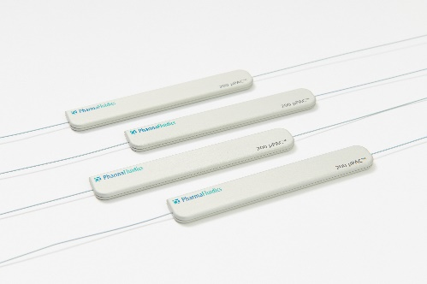After the introduction of a **200 cm long column**, which is ideally suited to perform comprehensive proteome research, a **50 cm long μPAC™ column** is also available which can be used in a more routine research setting. With an internal volume of 3 μL, this column is perfectly suited to perform high throughput analyses with shorter gradient solvent times (30, 60 and 90 minute gradients) and it can be used over a wide range of flow rates, between 100 and 2000 nL/min.

Recently performed experiments with 500 ng of HeLa cell digest indicate that an increase in protein identifications up to 50% and a gain of 70% in peptide identifications can be achieved when comparing the 50 cm μPAC™ column to the current state-of-the-art packed bed columns.

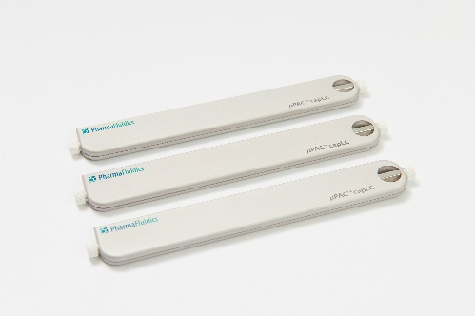Early this year, also a **µPAC™ capLC column** was launched that provides a versatile output in terms of separation performance and throughput. As a consequence of the low column back pressure, the same column can be operated over a range of **flow rates (1-15 µL/min)**, enabling analytical scientists to tune LC methods according to the sample complexity or to the size of the sample set.

*“Exchanging columns is a necessary evil [...]. However, the µPAC™ has been running for over five months continuously , taking several thousands of injections[...].”  
Dr. Duncan Smith – Head of Mass Spectrometry*

Visit our website to learn more!  
<button><https://www.pharmafluidics.com/></button>