The Cutting Edge: New Molecular and Staining Techniques

for Lymphoma and Mast Cell Tumors

Kendal Harr, DVM, DACVP

URIKA, LLC

Mukilteo, WA

The goal of this lecture is to update the general practitioner on new diagnostics that are recommended to assess two of the most common neoplasias in dogs, lymphoma and mast cell tumor.

Lymphoma

Lymphoma (malignant lymphoma, lymphosarcoma) is a neoplastic proliferation of lymphoid cells that arises in extramedullary tissue, including the lymph nodes, liver, spleen and gastrointestinal tract. The most common form of lymphoma seen in dogs is the multicentric form (arising in lymph nodes), whereas in cats, internal lymphomas (thymic, gastrointestinal, renal) are more frequent. Some patients with Stage V lymphoma have circulating neoplastic lymphoblasts or lymphocytes, which are able to be detected in peripheral blood smears. This is termed lymphoma cell leukemia. Some of these animals may not have identifiable infiltrates in their bone marrows. Circulating neoplastic cells are readily identified if they have blast morphology (large cells with nucleoli) and are present in large numbers in peripheral blood. However, low numbers of lymphoblasts must be differentiated from reactive lymphocytes and monocytes. A small or intermediate cell lymphoma is more difficult to detect on blood smear examination because the circulating neoplastic cells are difficult to distinguish from normal peripheral lymphocytes. Polymerase chain reaction (PCR) testing for clonal gene rearrangements in the T cell receptor or immunoglobulin genes has shown that many animals with lymphoma have clonally arranged genes, suggesting that they are leukemic, even if lymphoma cells are not detectable in their blood by morphological criteria. Bone marrow aspiration is performed for staging lymphoma: lymphoma infiltrates can be present in the marrow of animals with or without detectable circulating lymphoma cells. Indeed, many cats with spinal lymphoma will have marrow infiltrates without detectable blasts in blood. In the marrow, lymphoma cells are typically identified amongst a normal hematopoietic population (and can be very difficult to distinguish from myelo- or erythroblasts when in low numbers), with the infiltrates ranging from patchy to diffuse. A bone marrow that has been severely infiltrated with lymphoma may be very difficult to distinguish from an acute leukemia. This is seen more commonly in splenic or hepatic lymphomas in dogs. Lymphoma cell leukemias are more common in dogs than in cats, but have been seen in cats with thymic, hepatic and splenic lymphoma.

Lymphoma cell leukaemias can usually be distinguished from an acute leukemia (which arises primarily in the bone marrow) by:

1. The absence of other cytopenias. Cytopenias, if present, are usually mild (usually anaemia and/or thrombocytopenia) and related to chronic (inflammatory) disease. In rare cases, lymphoblasts can almost replace the marrow, which is difficult to distinguish from an acute leukaemia
2. Clinical evidence of lymphoma in extramedullary tissues (e.g., lymphadenopathy)
3. Immunophenotyping: CD 34 is a stem cell marker and positive in cells found in the bone marrow. All lymphomas are CD34 negative whereas acute leukemias are CD34 positive.

There are now numerous CD markers that are used in panels to identify different subsets of neoplastic lymphocytes which can help better identify the type of lymphoma and guide therapy for specific lymphocyte subsets. The following is an example of what one might receive as report. We will discuss these reports and work our way through meaning of the different CD markers and what they mean in your clinical decision making with some case presentations.

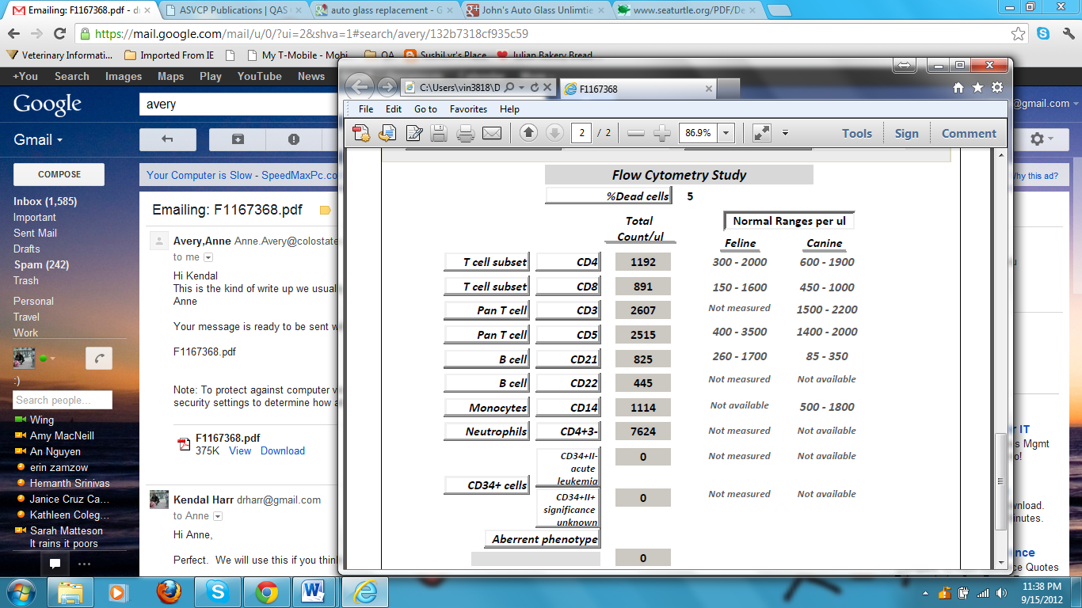Figure is from a case of T cell lymphoma arising in the gastrointestinal tract in a dog. This report is one given by Dr. Anne Avery at Colorado State University.

Mast cell tumor

In 1999, the presence of mutations in the gene c-kit in canine mast cell tumors was described.(London, Ma) C-kit is a receptor tyrosine kinase for stem cell factor (SCF), which stimulates mast cell growth. Both reports described small duplications of DNA within the c-kit gene called internal tandem duplications (ITDs). These mutations were found within exons 11 and 12 of the c-kit gene.

In one study, of 14 dogs with poor resection potential of their mast cell tumor, 8 dogs had no mutation identified, 1 had an exon 8 mutation, and 5 had exon 11 mutations. (Carlsten) The median PFI of dogs with mutant c-kit was 188.5 days (27 weeks) and was not reached in dogs with wild-type c-kit as followup terminated at one year. No dogs with c-kit mutant MCT and 87.5% of dogs with c-kit wild-type MCT were disease-free at 1 year. There was no statistical difference in overall ST based on c-kit mutation status (P = .25). At 1 year, 66.7% of dogs with c-kit mutant MCT and 100% of dogs with c-kit wild-type MCT were alive. This is with aggressive medical therapy including radiation, proceranib, and prednisone. So C-kit mutation is a strong and reliable negative prognostic indicator.

Webster and coworkers demonstrated that in cases treated by surgical excision alone (no chemotherapy), the presence of a mutation in exon 11 was highly correlated with a poor outcome. Subsequently, the same group evaluated the response to vinblastine and prednisone in 28 dogs and found that dogs with an exon 11 mutation had a disease-free interval of 6.5 months compared to those without this mutation (11 months).

This makes sense if one understands the pathogenesis. When C-kit is permanently phosphorylated, as it is when exon 11 is mutated, the receptor is permanently or constitutively activated and begins the signaling pathway which stimulates division of the mast cells. This is the cause of inappropriate cellular replication in the neoplastic process. This also occurs in some of the recently elucidated mutations.

C-kit mutation is therefore a prognostic indicator which can be assessed from either cytologic or histologic samples. It is quite useful to assess when the mast cell tumor is initially aspirated as it helps determine necessary treatment plan. If C-kit is mutated at one of the sites that causes permanent activation, then a more aggressive treatment plan that includes surgical resection, radiation, and aggressive medical therapy should be instituted. Additionally, referral to a boarded oncologist should be recommended to the owner. Dogs with recurrent mast cell disease responded better to the tyrosine kinase inhibitor Palladia if they carried the exon 11 c-kit mutation than if they did not. (London, 2009)

Additional markers may be used used on histopathology samples include Ki67. While this marker is helpful, data is more equivocal and will be discussed.

References

Vernau, W; Moore, PF. An immunophenotypic study of canine leukemias and preliminary assessment of clonality by polymerase chain reaction. Veterinary Immunology and Immunopathology 1999; 19: 145-164.

McDonough, SP; Moore, PF. Clinical, hematologic, and immunophenotype characterization of canine large granular lymphocytosis. Veterinary Pathology 2000; 37: 637-646.

Avery, PR; Avery, AC. Molecular methods to distinguish between reactive and neoplastic lymphocyte expansion and their importance in transitional neoplastic states. Veterinary Clinical Pathology 2004; 33: 196-207.

Carlsten KS, London CA, Haney S, Burnett R, Avery AC, Thamm DH. Multicenter prospective trial of hypofractionated radiation treatment, toceranib, and prednisone for measurable canine mast cell tumors. J Vet Intern Med. 2012

Jan-Feb;26(1):135-41.

London CA, Galli SJ, Yuuki T, et al. Spontaneous canine mast cell tumors express tandem duplications in the proto-oncogene c-kit. Exp Hematol 1999;27:689–97

London CA, Malpas PB, Wood-Follis SL, et al. Multi-center, placebo-controlled, double-blind, randomized study of oral toceranib phosphate (SU11654), a receptor tyrosine kinase inhibitor, for the treatment of dogs with recurrent (either local or distant) mast cell tumor following surgical excision. Clin Canc Res 2009;15:3856–65.

Ma Y, Longley BJ, Wang X, et al. Clustering of activating mutations in c-KIT’s juxtamembrane coding region in canine mast cell neoplasms. J Inv Dermatol 1999; 112:165–70.

Webster JD, Yuzbasiyan-Gurkan V, Kaneene JB, et al. The role of c-KIT in tumorigenesis: evaluation in canine cutaneous mast cell tumors. Neoplasia (New York) 2006;8:104–11.

Webster JD, Yuzbasiyan-Gurkan V, Thamm DH, et al. Evaluation of prognostic markers for canine mast cell tumors treated with vinblastine and prednisone. BMC Vet Res 2008;4:32.